Reading Babe Ruth League Fall Clinic
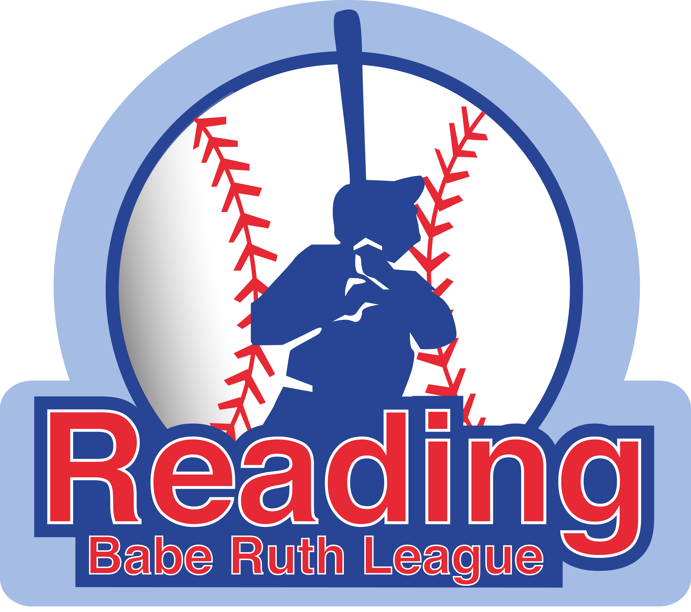
With One on One Fundamentals
Registration Form

Name: _________________________________________ Email: _________________________________________

Address: ________________________________________________________ Age (as of 8/31/20) ____________

City: ________________________________State:_______________________ Zip Code: ______________________

Home Phone: ( ) _________________________ Alt Phone: ( ) _______________________________

Liability Release Form

I/We the parent(s)/guardian(s) of the above-mentioned minor child, hereby give my/our approval to his/her participation in the program. I/We assume all risks and hazards incidental to such participation: and I/We do hereby waive, release, absolve, indemnify and agree to hold harmless One on One Fundamentals, its organizers, sponsors, supervisors and staff for any claim arising out of an injury to my/our child to the extent covered by accident or liability insurance.

Signature: ___________________________________ Date: _____________________________
(Parent/Guardian)
---------------------------------------------------------------------------------------------------------------------------------------------
Please enroll my child in the following:

1) 2019 Fall Baseball Clinic Cost: $100.00
Ages: 13-15 as of 8/31/20

8 Saturdays (10:00 am to 1:00 pm)

Dates are: 9/7, 9/14, 9/21, 10/5, 10/12, 11/2, 11/9, 11/16

As we do every year, we will continue as long as the weather allows us to.

Place: - Washington Park

Please make checks payable to David Gray.

Registration(s) and payment (s) are due ASAP!

Please drop off or mail to:
One on One Fundamentals
C/o David Gray
29 Libby Avenue
Reading, Ma 01867

You can also pay online at www.oneononefundamentals.com

If you have any questions and/or comments, please contact David Gray at (781) 706-1136 or email coachgray15@verizon.net

